Terraform-Microservice-Challenge
Goal of the Exercise
The goal of this exercise is to test your understanding of a Cloud Compute deployment with Terraform.
You are tasked with creating a codebase for a microservice deployment on a cloud environment, using Terraform. Since our focus is not the application itself, the service will be a simple web server that returns a static page.
Requirements
Service Details
- The service will be a simple web server that returns a static page.
- You can useapache2ornginxto serve a simple HTML file.
- The service should becontainerizedand stored in aDocker registry.
- The service should be deployed on asingle VM instanceas a docker container.
- The image should be pulled from the registry specified earlier.
- The service shouldnotbe accessible from the internet but only through aLoad Balancer, except for SSH access from specific IP addresses.
Deliverables
You are to provide the following as part of your solution:
- Dockerfileto build the image.
- Terraform codebaseto deploy the following:
  - Docker registry
  - VPC and all required networking resources
  - EC2 instance
  - Load Balancer
Notes
- Since a CI/CD pipeline is not part of this exercise, we will work around that with the help of Terraform.
- To push the image to the Docker registry,build the image locallybefore running the Terraform code.
- Once the image registry is created, use Terraform topush the local imageto the registry.
- Similarly, use Terraform topull the imagefrom the registry and run it on the VM instance once it is created.
- For SSH access:
  - Use a locally created key.
  - Add it to the cloud provider key storage.
  - Attach it to the instance.
- UseTerraform best practicesfor file structure and code organization.
  - Use variables, locals, modules, etc. when appropriate.
- Include alltfvars, scripts, and other helper files used to deploy the application.
- You may use any cloud provider of your choosing, althoughAWS is preferred.
- Use afree tier accountor atrial accountto deploy the resources.
Now local cli do the aws configure and check the version of docker and terraform
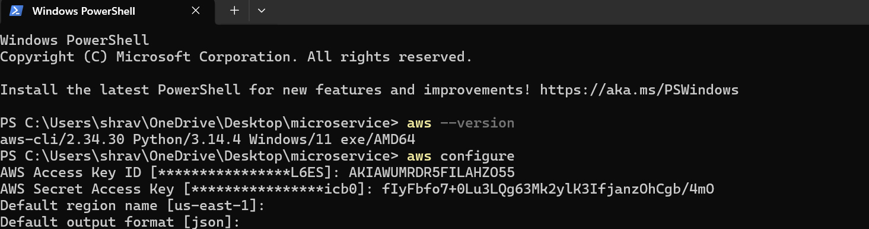
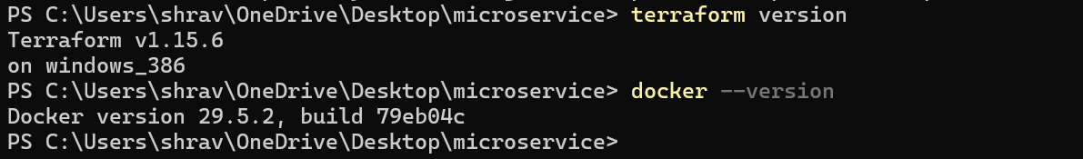
Now create a folder app and then inside create a Dockerfile and index.html
Inside the index.html
<!DOCTYPE html>
<html>
<body>
<h1>Hello from Terraform Deployment!</h1>
</body>
</html>
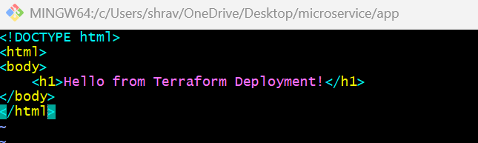
Inside the Dockerfile.html
FROM nginx:alpine
COPY index.html /usr/share/nginx/html/index.html
EXPOSE 80
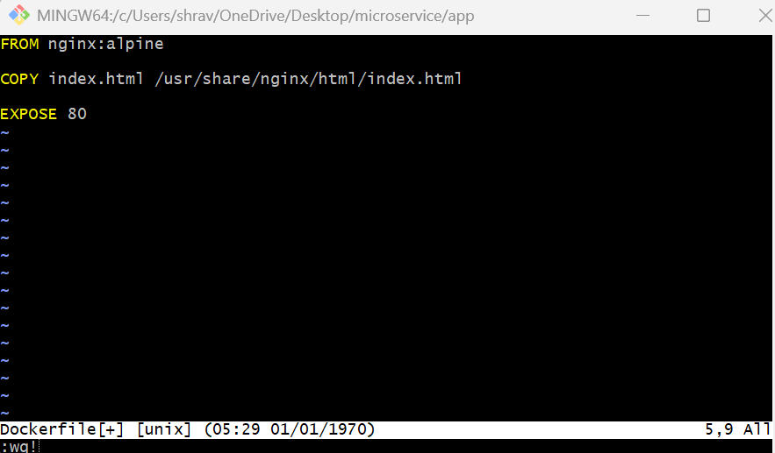
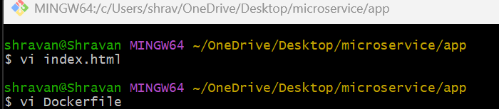
Docker build -t my-web-app
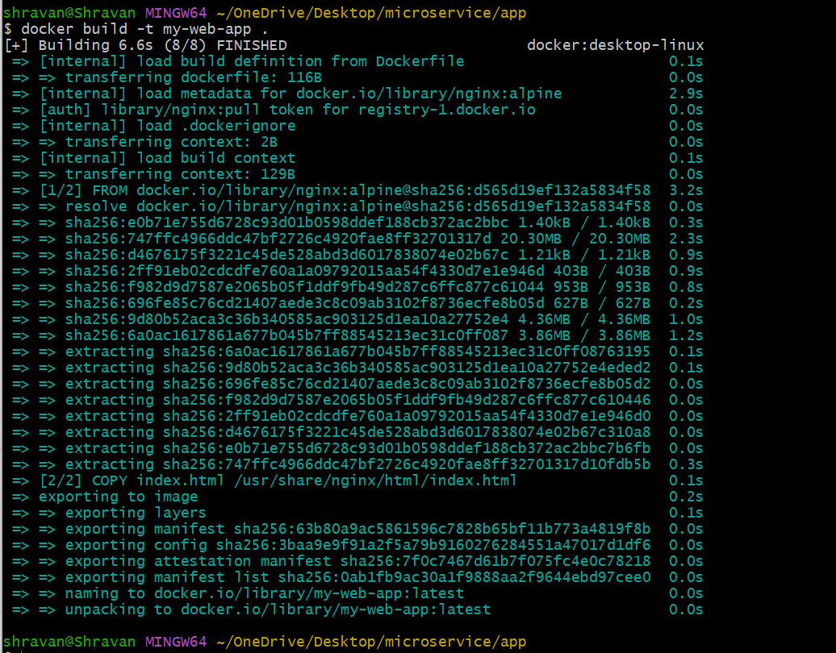
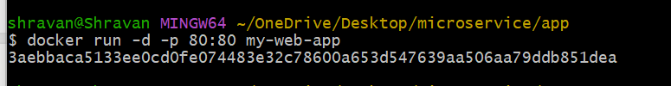
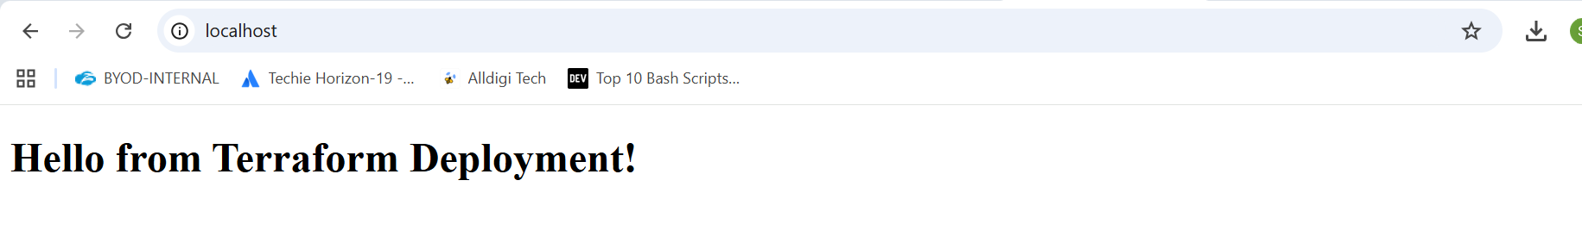
terraform-microservice/
├── app/
│ ├── Dockerfile
│ └── index.html
│
└── terraform/
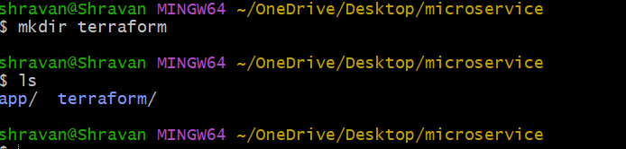
Now create the ecr using terraform script
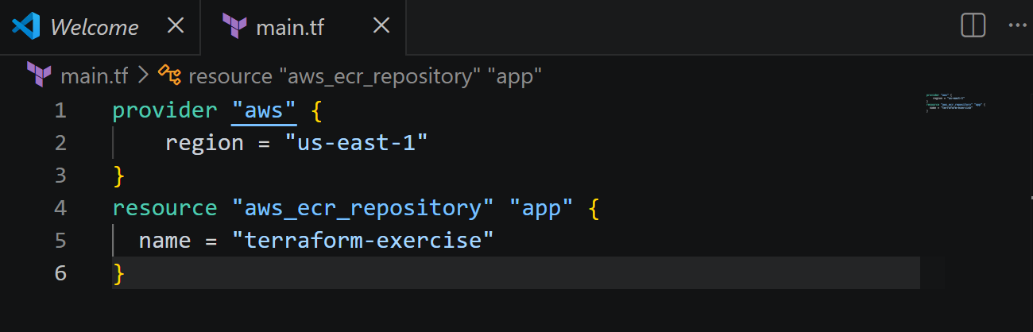
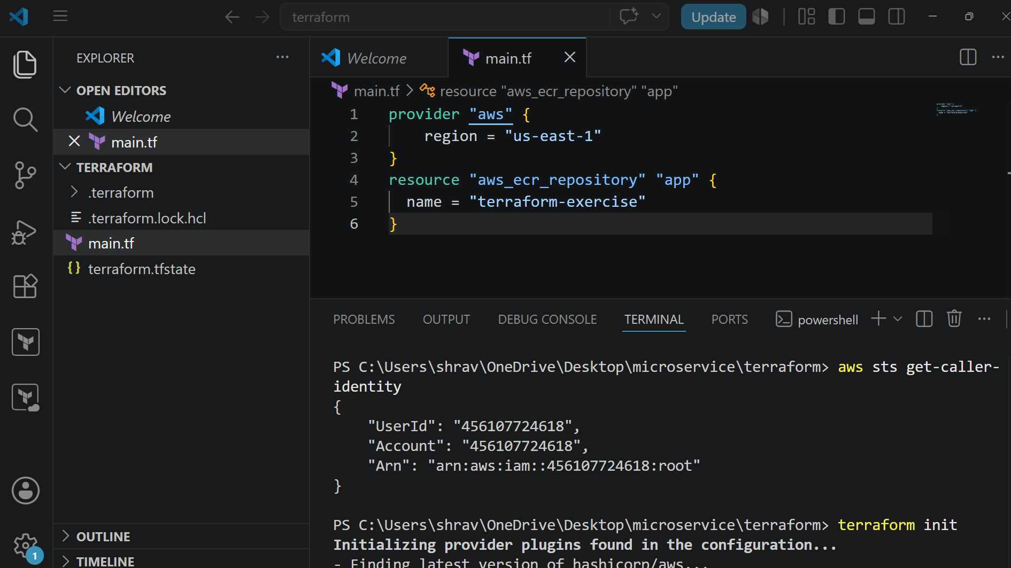
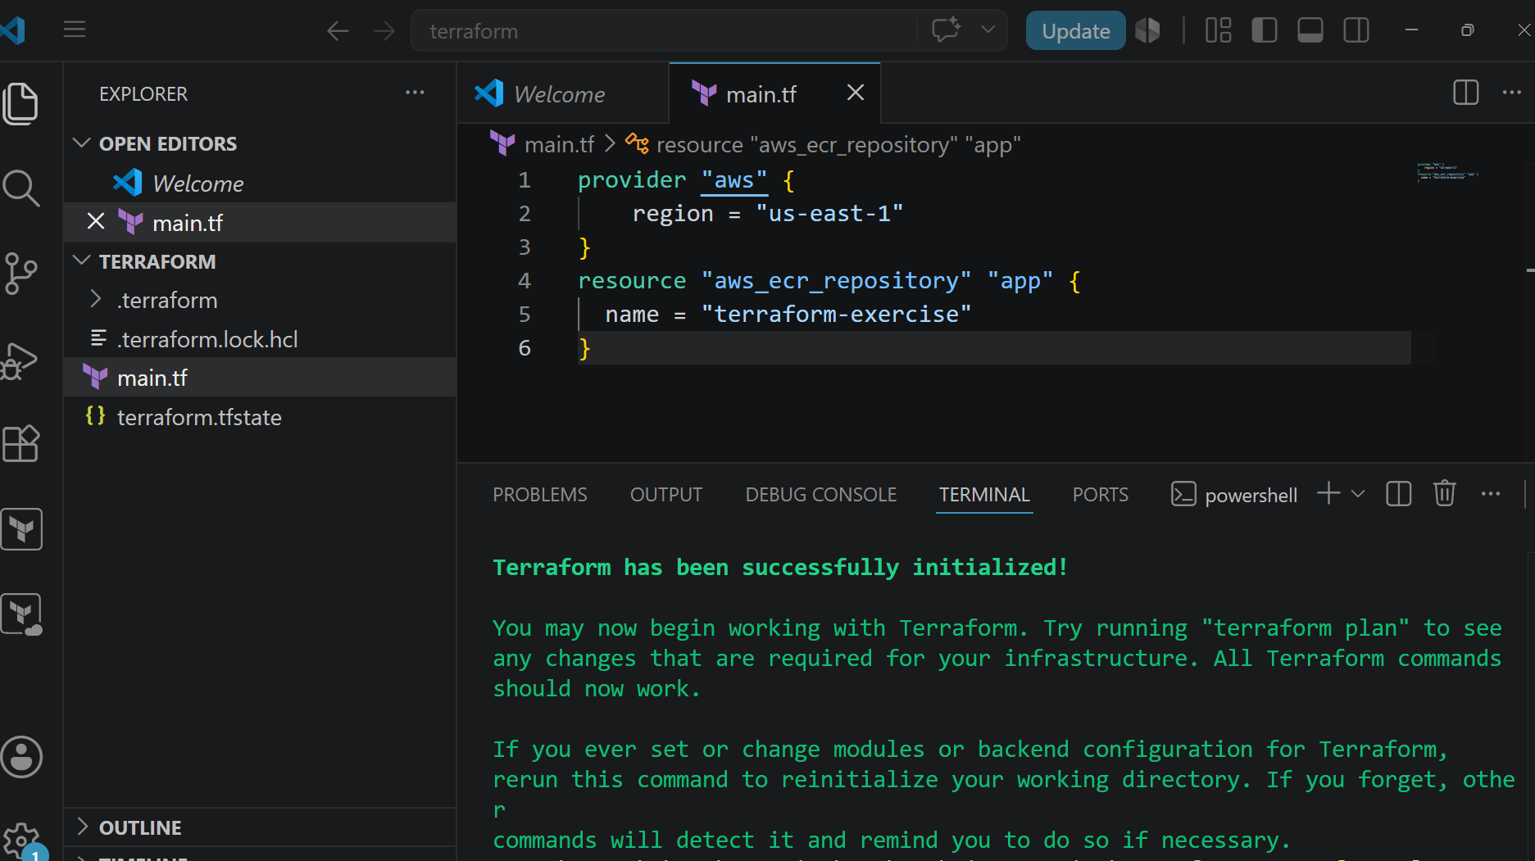
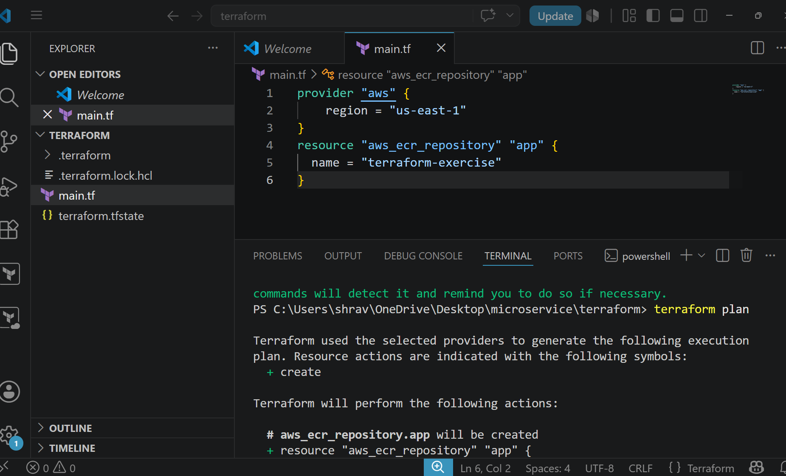
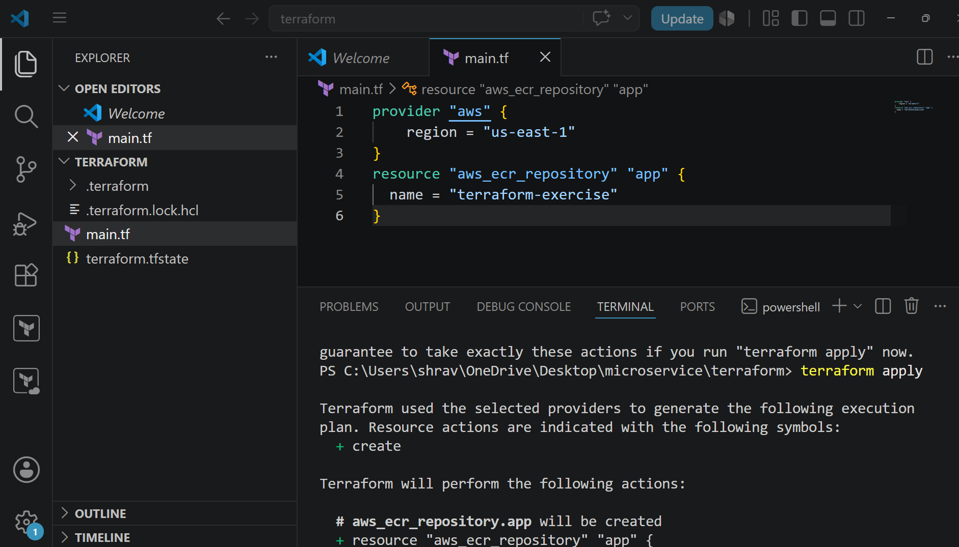
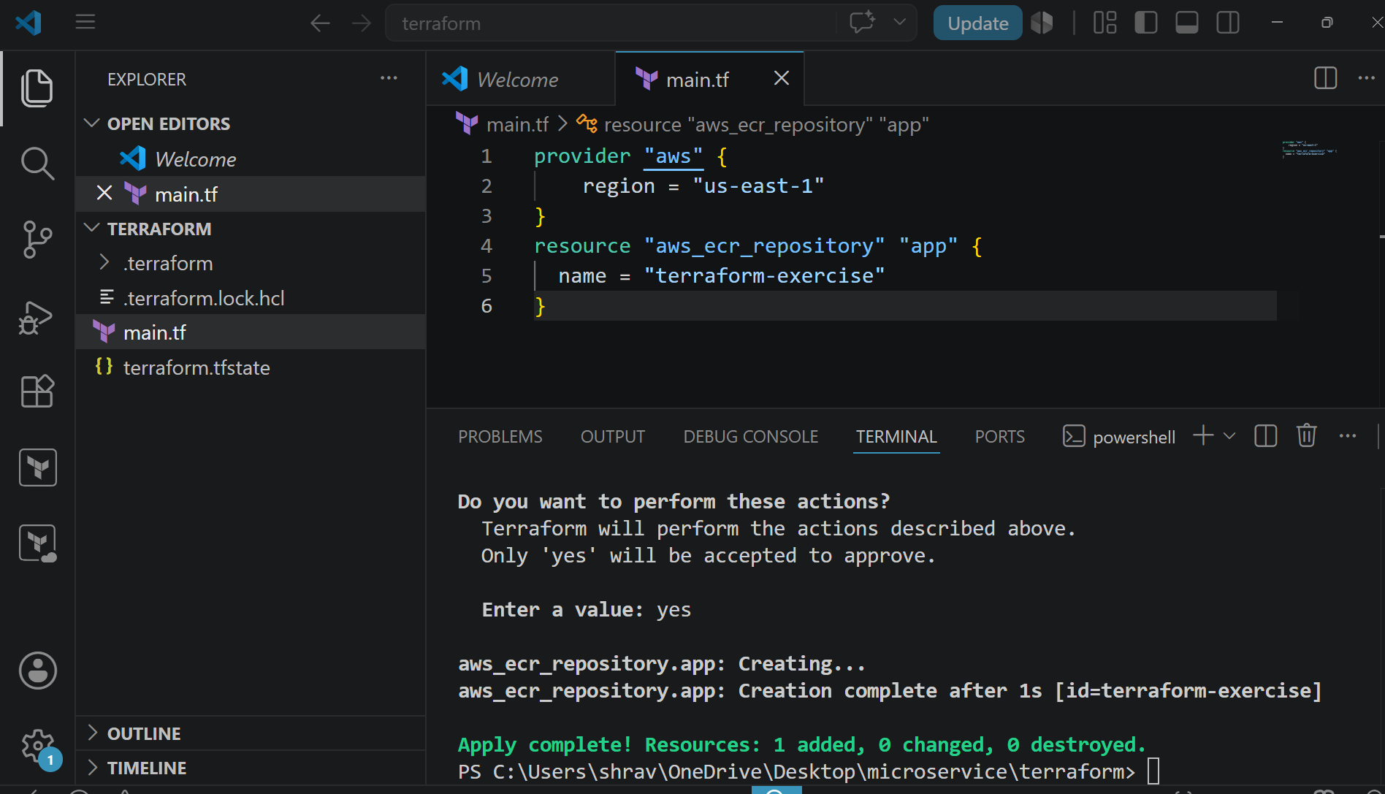
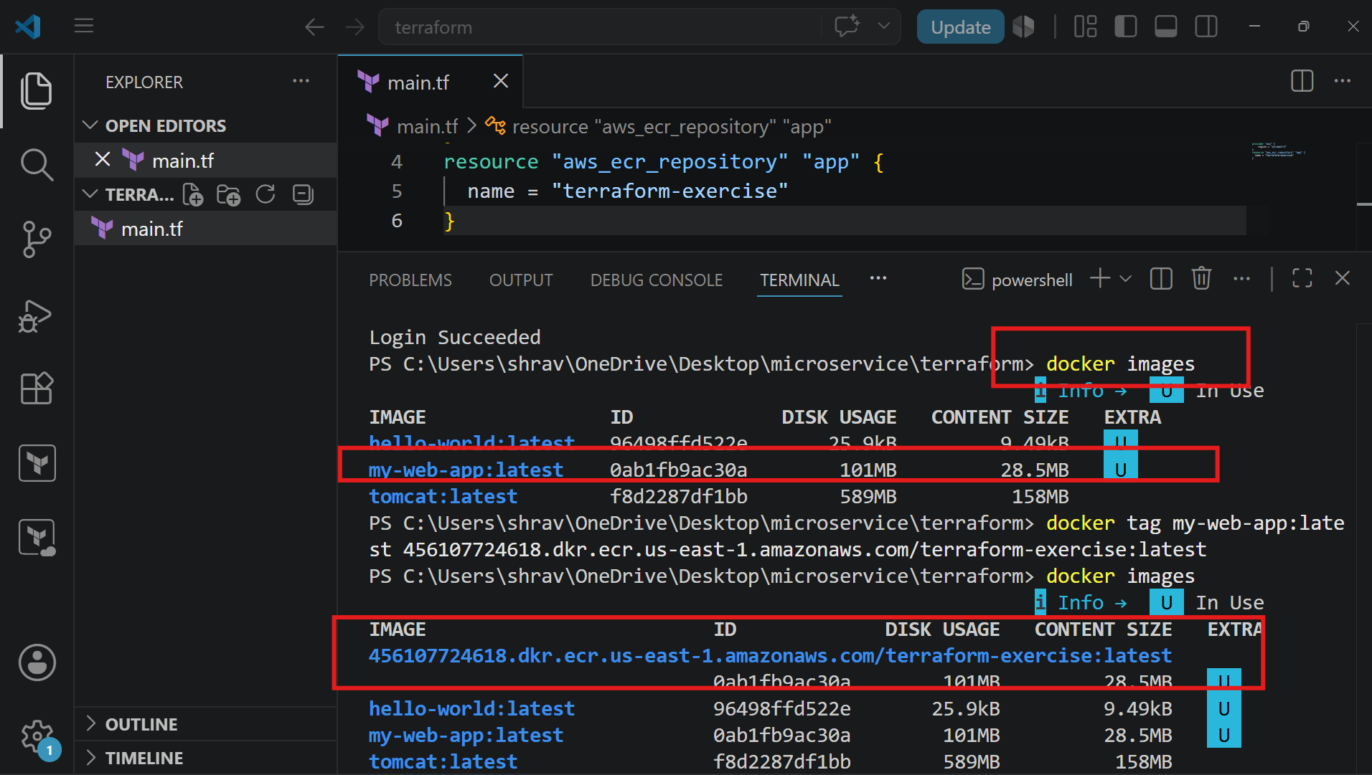
Now do docker push
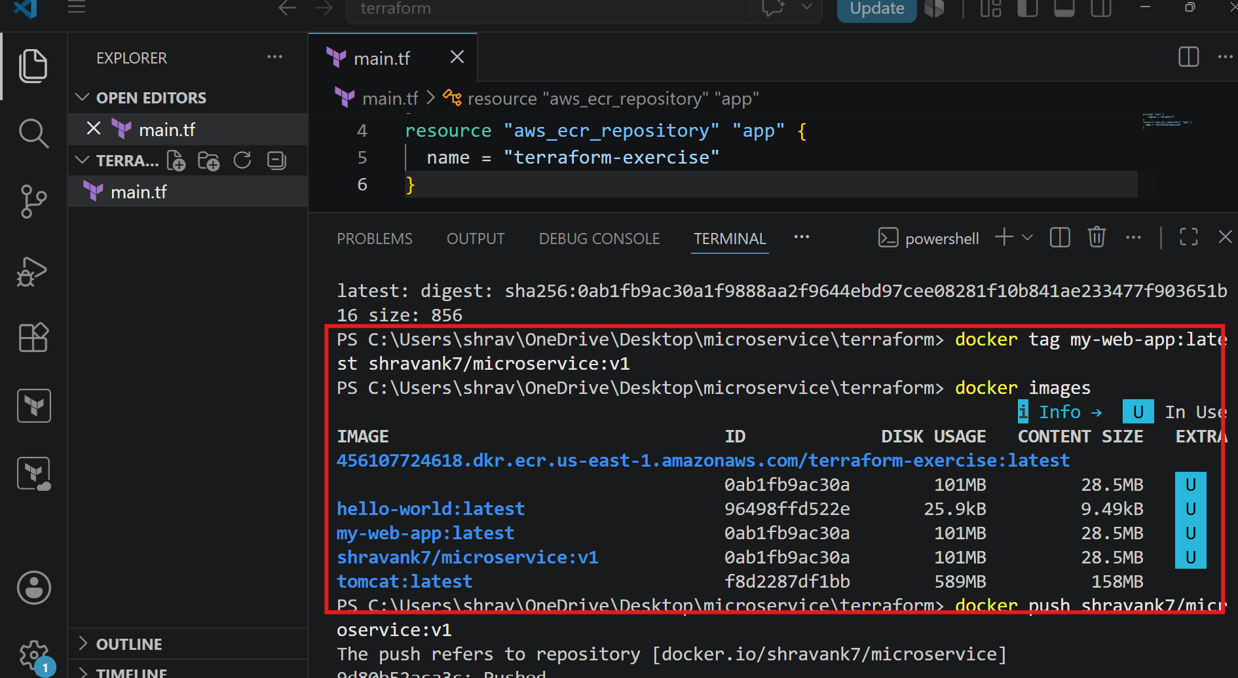
Image is successfully pushed
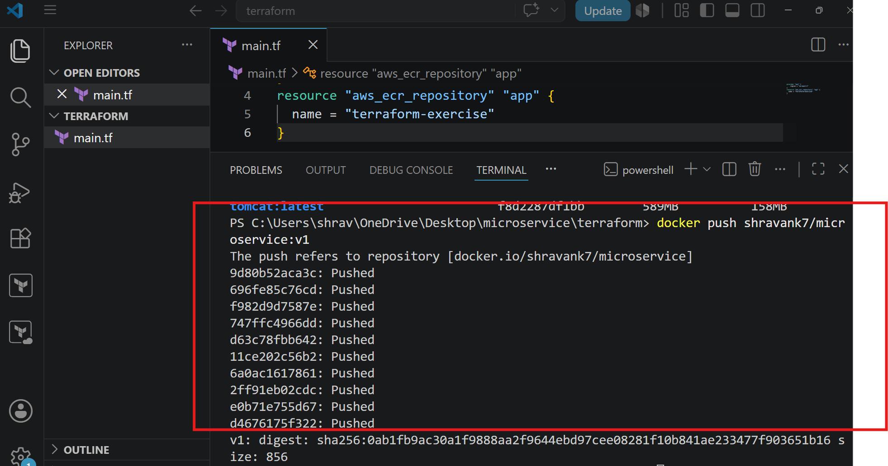
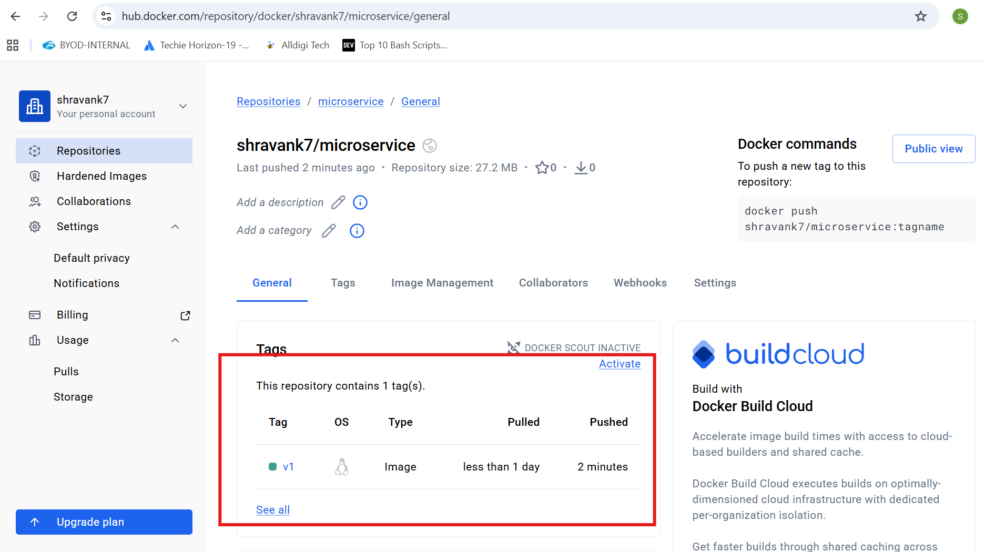
AWS Microservice Deployment Using Terraform
Overview
This Terraform project provisions an AWS infrastructure for deploying a Docker-based microservice application.
The infrastructure includes:
- AWS VPC
- Public subnets across multiple Availability Zones
- Internet Gateway
- Public routing
- Security Groups
- Application Load Balancer (ALB)
- EC2 instance
- Docker container deployment
- ALB to EC2 traffic routing
The EC2 instance automatically installs Docker and runs the microservice container from Docker Hub.

Architecture
Internet
|
|
Application Load Balancer
|
------------------------
| |
Public Subnet 1 Public Subnet 2
|
|
EC2 Instance
|
Docker Container
|
shravank7/microservice:v1

Files Structure
terraform-project/
│
├── main.tf
├── variables.tf
├── terraform.tfvars
└── output.tf

Provider Configuration
AWS Provider
The project uses AWS as the cloud provider.
provider "aws" {
region = "us-east-1"
}
Region:
us-east-1
All resources are created in the North Virginia AWS region.

Availability Zones
Terraform dynamically fetches available AWS Availability Zones.
data "aws_availability_zones" "available" {}
These AZs are used for creating highly available public subnets.
Example:
AZ-1
AZ-2

VPC Configuration
A Virtual Private Cloud is created.
resource "aws_vpc" "main"
CIDR:
10.0.0.0/16
This provides:
65,536 private IP addresses
Enabled:
- DNS Support
- DNS Hostnames

Internet Gateway
The Internet Gateway allows communication between AWS resources and the public internet.
Resource:
aws_internet_gateway
Attached to:
main VPC

Public Subnets
Two public subnets are created.
Public Subnet 1
CIDR:
10.0.1.0/24
Availability Zone:
First available AZ

Public Subnet 2
CIDR:
10.0.2.0/24
Availability Zone:
Second available AZ
Both subnets have:
map_public_ip_on_launch = true
Meaning:
EC2 instances receive public IP addresses automatically.

Public Route Table
A route table is created for internet access.
Route:
Destination:
0.0.0.0/0

Target:
Internet Gateway
Traffic flow:
EC2
|
Route Table
|
Internet Gateway
|
Internet

Security Groups
Security groups control network access.

ALB Security Group
Name:
alb-sg
Allows:
HTTP traffic
Port:
80
Source:
0.0.0.0/0
Meaning:
Anyone on the internet can access the load balancer.

EC2 Security Group
Name:
ec2-sg
Allows:
SSH Access
Port:
22
Allowed IP:
103.24.20.196/32
Only this IP can SSH into EC2.

Application Traffic
Port:
80
Source:
ALB Security Group
Only the load balancer can access the application.

Application Load Balancer
Resource:
aws_lb.alb
Type:
Application Load Balancer
Name:
micro-alb
Runs in:
public_1
public_2
Purpose:
- Receive internet traffic
- Forward requests to EC2

Target Group
Resource:
aws_lb_target_group.tg
Configuration:
Protocol:
HTTP
Port:
80
Health check:
/
ALB continuously checks whether the application is healthy.

Listener
Listener configuration:
Port:
80
Protocol:
HTTP
Traffic flow:
User
|
ALB :80
|
Target Group
|
EC2 :80

AMI Selection
Terraform searches the latest Amazon Linux 2023 AMI.
data "aws_ami"
Filters:
al2023-ami-*-x86_64
Owner:
amazon

EC2 Instance
Resource:
aws_instance.app
Configuration:
Instance Type:
t3.micro
Operating System:
Amazon Linux 2023
Subnet:
public_1
Public IP:
Enabled
SSH Key:
jenkins

EC2 User Data
When EC2 starts, the script executes automatically.
Steps:
1. Install Docker
dnf install -y docker

2. Start Docker Service
systemctl enable docker
systemctl start docker

3. Pull Application Image
Docker image:
shravank7/microservice:v1

4. Remove Old Container
docker rm -f web

5. Start Application Container
docker run -d \
--name web \
--restart=always \
-p 80:80 \
shravank7/microservice:v1
Application runs on:
EC2 Port 80

Load Balancer Attachment
The EC2 instance is registered with the target group.
Resource:
aws_lb_target_group_attachment
Flow:
ALB
|
Target Group
|
EC2 Instance

Variables
variables.tf
SSH Allowed IP
variable "allowed_ssh_ip"
Used for restricting SSH access.
Value:
103.24.20.196/32

Key Pair
variable "key_name"
Used to SSH into EC2.
Value:
jenkins

Terraform Variables File
terraform.tfvars
allowed_ssh_ip = "103.24.20.196/32"

key_name = "jenkins"

Outputs
output.tf
Returns ALB DNS name.
output "alb_dns"
After deployment:
Example:
micro-alb-xxxx.us-east-1.elb.amazonaws.com
Application URL:
http://<alb_dns>

Deployment Steps
Initialize Terraform
terraform init
Validate Configuration
terraform validate
Create Execution Plan
terraform plan
Deploy Infrastructure
terraform apply
Confirm:
yes

Final Application Flow
Client Browser
|
|
v
Application Load Balancer
|
|
v
Target Group
|
|
v
EC2 Instance
|
|
v
Docker Container
|
|
v
Microservice Application

Security Summary
Component | Access
ALB | Public HTTP
EC2 SSH | Restricted IP
EC2 HTTP | Only ALB
Docker App | Port 80
Internet | Through ALB

provider "aws" {
region = "us-east-1"
}
################################
# Availability Zones
################################
data "aws_availability_zones" "available" {}
################################
# VPC
################################
resource "aws_vpc" "main" {
cidr_block = "10.0.0.0/16"
enable_dns_support = true
enable_dns_hostnames = true
}
################################
# Internet Gateway
################################
resource "aws_internet_gateway" "igw" {
vpc_id = aws_vpc.main.id
}

################################
# Public Subnets
################################
resource "aws_subnet" "public_1" {
vpc_id = aws_vpc.main.id
cidr_block = "10.0.1.0/24"
availability_zone = data.aws_availability_zones.available.names[0]
map_public_ip_on_launch = true

resource "aws_subnet" "public_2" {
vpc_id = aws_vpc.main.id
cidr_block = "10.0.2.0/24"
availability_zone = data.aws_availability_zones.available.names[1]
map_public_ip_on_launch = true
}
################################
# Route Table (Public)
################################
resource "aws_route_table" "public" {
vpc_id = aws_vpc.main.id
route {
cidr_block = "0.0.0.0/0"
gateway_id = aws_internet_gateway.igw.id
}
}
resource "aws_route_table_association" "pub1" {
subnet_id = aws_subnet.public_1.id
route_table_id = aws_route_table.public.id
}
resource "aws_route_table_association" "pub2" {
subnet_id = aws_subnet.public_2.id
route_table_id = aws_route_table.public.id
}
################################
# Security Groups
################################
resource "aws_security_group" "alb_sg" {
name = "alb-sg"
vpc_id = aws_vpc.main.id
ingress {
from_port = 80
to_port = 80
protocol = "tcp"
cidr_blocks = ["0.0.0.0/0"]
}
egress {
from_port = 0
to_port = 0
protocol = "-1"
cidr_blocks = ["0.0.0.0/0"]
}
}
resource "aws_security_group" "ec2_sg" {
name = "ec2-sg"
vpc_id = aws_vpc.main.id

ingress {
from_port = 22
to_port = 22
protocol = "tcp"
cidr_blocks = [var.allowed_ssh_ip]
}
ingress {
from_port = 80
to_port = 80
protocol = "tcp"
security_groups = [aws_security_group.alb_sg.id]
}
egress {
from_port = 0
to_port = 0
protocol = "-1"
cidr_blocks = ["0.0.0.0/0"]
}
}
################################
# Load Balancer
################################
resource "aws_lb" "alb" {
name = "micro-alb"
load_balancer_type = "application"
security_groups = [aws_security_group.alb_sg.id]
subnets = [
aws_subnet.public_1.id,
aws_subnet.public_2.id
]
}
resource "aws_lb_target_group" "tg" {
port = 80
protocol = "HTTP"
vpc_id = aws_vpc.main.id
health_check {
path = "/"
}
}
resource "aws_lb_listener" "listener" {
load_balancer_arn = aws_lb.alb.arn
port = 80
protocol = "HTTP"
default_action {
type = "forward"
target_group_arn = aws_lb_target_group.tg.arn
}
}
################################
# AMI (Amazon Linux 2023 x86)
################################
data "aws_ami" "linux" {
most_recent = true
owners = ["amazon"]
filter {
name = "name"
values = ["al2023-ami-*-x86_64"]
}

################################
# EC2 Instance (PUBLIC)
################################
resource "aws_instance" "app" {
ami = data.aws_ami.linux.id
instance_type = "t3.micro"
subnet_id = aws_subnet.public_1.id
associate_public_ip_address = true
vpc_security_group_ids = [aws_security_group.ec2_sg.id]
key_name = var.key_name
user_data = <<EOF
#!/bin/bash
exec > /var/log/user-data.log 2>&1
# Install Docker (AL2023 + AL2 safe)
dnf install -y docker || yum install -y docker
systemctl enable docker
systemctl start docker
# Wait for network
sleep 20
docker pull shravank7/microservice:v1
docker rm -f web || true
docker run -d \
--name web \
--restart=always \
-p 80:80 \
shravank7/microservice:v1
EOF
}
################################
# Attach EC2 to Target Group
################################
resource "aws_lb_target_group_attachment" "attach" {
target_group_arn = aws_lb_target_group.tg.arn
target_id = aws_instance.app.id
port = 80
}

